Kingdom of Saudi Arabia  Ministry of Education  Eastern Province Education Department  Tarbeat Al-Ajial International Schools |  |  |  |  |  |  | Date: ……/………/..………  Subject: Computer  Grade: G2
……………… |  | Seat Number |  | ……………………………………….. |  |  |  | Student’s Name
2nd Semester Exam (1St Session) 2026/2025
Sign. | Consultative Name |  | Sign. |  | Corrector’s Name | Marks in letters |  |  | Marks  in numbers
 |  |  |  |  |  |  |  |  | 40
Question A: Match the following

 | Digital Camera
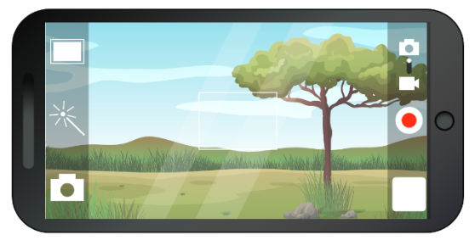 | Webcam
 | Smartphone
 | WAV
 | MP3

Question B: State whether ( True ) or ( False )

- To capture an image is an art called photography.
  - True b. False

- File type is also called as File format
  - True b. False

- wav is a type of Audio format.
  - True b. False

- "Add title card" is an option used to add a slide for introduction.
  - True b. False


Question C: Tick mark ((✔️ on the empty folder
✔️
Good Luck
Good Luck

